**Ensure text remains visible during webfont load**

May 2, 2019 • Updated Apr 29, 2020

Appears in: [Performance audits](https://web.dev/lighthouse-performance)

Fonts are often large files that take awhile to load. Some browsers hide text until the font loads, causing a [flash of invisible text (FOIT)](https://web.dev/avoid-invisible-text).

**How the Lighthouse font-display audit fails** [**#**](https://web.dev/font-display/?utm_source=lighthouse&utm_medium=devtools#how-the-lighthouse-font-display-audit-fails)

[Lighthouse](https://developers.google.com/web/tools/lighthouse/) flags any font URLs that may flash invisible text:

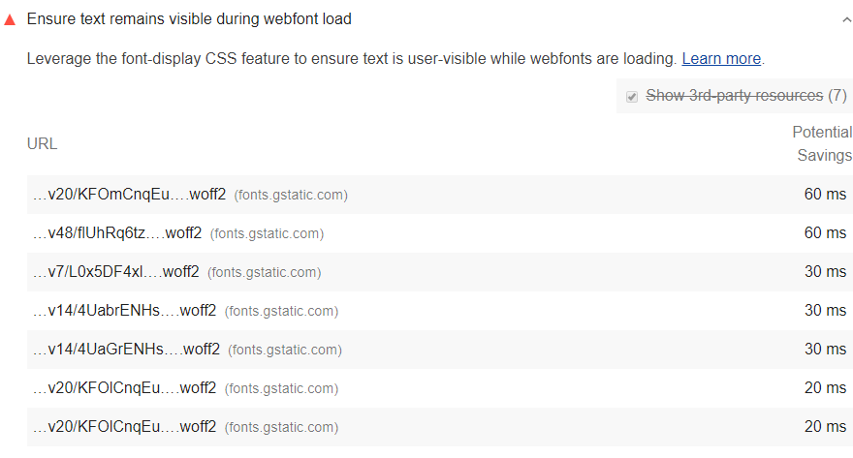

See the [Lighthouse performance scoring](https://web.dev/performance-scoring) post to learn how your page's overall performance score is calculated.

**How to avoid showing invisible text** [**#**](https://web.dev/font-display/?utm_source=lighthouse&utm_medium=devtools#how-to-avoid-showing-invisible-text)

The easiest way to avoid showing invisible text while custom fonts load is to temporarily show a system font. By including font-display: swap in your @font-face style, you can avoid FOIT in most modern browsers:

@font-face {  
 font-family: 'Pacifico';  
 font-style: normal;  
 font-weight: 400;  
 src: local('Pacifico Regular'), local('Pacifico-Regular'), url(https://fonts.gstatic.com/s/pacifico/v12/FwZY7-Qmy14u9lezJ-6H6MmBp0u-.woff2) format('woff2');  
 font-display: swap;  
}

The [font-display API](https://developer.mozilla.org/docs/Web/CSS/@font-face/font-display) specifies how a font is displayed. swap tells the browser that text using the font should be displayed immediately using a system font. Once the custom font is ready, it replaces the system font. (See the [Avoid invisible text during loading](https://web.dev/avoid-invisible-text) post for more information.)

**Preload web fonts** [**#**](https://web.dev/font-display/?utm_source=lighthouse&utm_medium=devtools#preload-web-fonts)

Use <link rel="preload" as="font"> to fetch your font files earlier. Learn more:

* [Preload web fonts to improve loading speed (codelab)](https://web.dev/codelab-preload-web-fonts/)
* [Prevent layout shifting and flashes of invisibile text (FOIT) by preloading optional fonts](https://web.dev/preload-optional-fonts/)

**Google Fonts** [**#**](https://web.dev/font-display/?utm_source=lighthouse&utm_medium=devtools#google-fonts)

Add the &display=swap [parameter](https://developer.mozilla.org/docs/Learn/Common_questions/What_is_a_URL#Basics_anatomy_of_a_URL) to the end of your Google Fonts URL:

<link href="https://fonts.googleapis.com/css?family=Roboto:400,700&display=swap" rel="stylesheet">

**Browser support** [**#**](https://web.dev/font-display/?utm_source=lighthouse&utm_medium=devtools#browser-support)

It's worth mentioning that not all major browsers support font-display: swap, so you may need to do a bit more work to fix the invisible text problem.

**Try it**! Check out the [Avoid flash of invisible text codelab](https://web.dev/codelab-avoid-invisible-text) to learn how to avoid FOIT across all browsers.